PWGSC WPSS Validation Tool

User Guide

Version 3.6
EDRM # 1067511
October 23, 2012

1 Introduction 4
1.1 Tool Limitations 4
1.2 Tool Risks 4
2 Installation 5
2.1 System Requirements 5
2.2 Remove Existing PL File Associations 5
2.3 Install WPSS Tool files 5
2.3.1 Perl Installation 6
2.3.2 Python Installation 6
3 Uninstall 7
3.1 Start Menu Method 7
3.2 Windows Explorer Method 7
3.3 Uninstalling Perl 7
3.4 Uninstalling Python 8
4 How To Use 9
4.1 Site Details 9
4.1.1 Entry URLs 9
4.2 Login/Logout Pages 11
4.2.1 Login/Logout URLs 12
4.3 Saving Site Details 13
4.3.1 Loading Site Details 13
4.4 Perform Site Crawl and Analyse Documents 13
4.5 Direct HTML Analyses 13
4.6 List of URLs 14
4.7 Tool Analysis Configuration 15
4.8 Results Window 18
4.8.1 Saving Analysis Results 19
4.8.2 Stopping Crawler and Analysis 20
4.9 Application Login 20
4.10 Web Server Protected Sites 20
4.11 Reporting Passes and Fails 21
4.12 Capture HTML Content on Errors 21
5 Command Line Interface 22
5.1 Crawl a Site 22
5.2 Crawl a site with a login 23
5.3 Analyse a block of HTML code 23
5.4 Analyse a list of URLs 24
5.5 Program Status and Progress 24
5.6 Viewing Results 25
5.7 Language Switching 25
6 Configuration Files 26
6.1 Domain Network Scope 26
6.2 Domain Alias Map 26
7 Trouble Shooting 27
7.1 Entry Page Rewritten 27
7.2 Forbidden by robots.txt 27
7.3 User Agent String 27
7.4 Perl Command Line Interpreter Error 27
7.5 500 Internal Server Error 28

Introduction

The PWGSC WPSS Validation Tool provides web developers and quality assurance testers the ability to perform a number of web site and web page validation tasks at one time. The tool crawls a site to find all of the documents then analyses each document with a number of validation tools. The analysis includes

- HTML Validation
- CSS Validation
- Robots.txt Validation
- Link Violation Checking
- Metadata Checking
- Technical Quality Assurance (TQA) Checking
- HTML Document feature reporting (e.g. forms)

Details of these analysis tools can be found in document “Web-WPSS Tool”.

Tool Limitations
There are limitations within the tool that may affect the validation results, these limitations are:

- The tools do not support JavaScript, sites that rely on JavaScript may not be crawled or analysed accurately.
- The tools do not use a standard Web browser User Agent name, sites that rely on the User Agent name may not be crawled or analysed accurately.
- The tools default behaviour is to respect robots directives, if a site has a robots.txt that prohibits crawlers, then no validation of the site’s documents would be performed. The tool can be configured to ignore robots.txt directives, see section “Tool Analysis Configuration” below.
- The output some of the individual validation tools is in English only. Users should be aware that this tool is using 3rd-party software components. The source of these components is available only in the language in which it was authored.

Tool Risks
This validation tool includes a crawler that will follow links and retrieve web documents from sites. Care should be taken with this tool to
- Ensure entry page URLs for the sites are accurate so the crawler does not go beyond the site being analysed.
- Ensure that document retrieval from the site being analysed, and any links to other sites, do not impose excessive loads on web servers and the network.

Installation

The PWGSC WPSS Validation Tool requires that a Perl distribution be installed on the workstation and that .pl files be associated with the Perl interpreter. This tool has been tested with ActivePerl version 5.10 and 5.14. Other versions of ActivePerl and other Perl installations may not work as expected or may be missing required modules.

System Requirements
- Windows XP or Windows 7
- Java run time environment 1.6.0 (other version, either newer or older, may not work).
- Python version 2.3 or later.
- Only 1 installation of Perl on the system. Multiple installations may cause problems.

The following software packages may be installed as part of the WPSS Tool
- Perl version 5.10 (other versions, either newer or older, may not work)
- Python version 2.7.3.

Remove Existing PL File Associations
Remove any existing .pl file type associations. The installation of ActivePerl will create a new association to ensure the proper execution of Perl programs.
- Open the Control Panel,
- Open the Folder Options tool
- Select the “File Types” tab
- Scan the file extensions list, select the .pl entry and click delete the association.

Install WPSS Tool files
Double click on the WPSS_Install.exe file and follow the instructions.

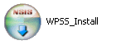

The default installation folder for the tool is
C:\Program Files\WPSS_Tool

Perl Installation
The install process tests to see if the workstation has Perl installed. If no Perl installation is found, the Perl installer is launched. Select all default settings in order to install Perl.

Python Installation
The install process tests to see if the workstation has Python installed. If no Python installation is found, the Python installer is launched. Select all default settings in order to install Python.

Uninstall
The tool can be removed from a workstation by running it’s uninstall script.

Start Menu Method
Select “start”, “Programs”, “WPSS_Tool”, “Uninstall”

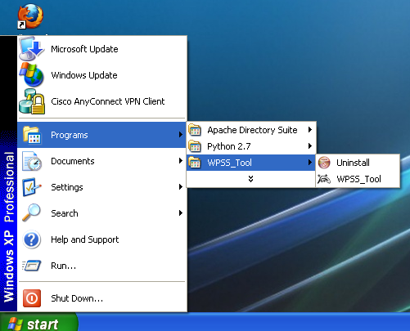

Windows Explorer Method
Using Windows Explorer navigate to the WPSS_Tool folder.
Run the uninst program.

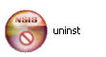

Uninstalling Perl
The Perl installation can be removed by using the “Control Panel”, “Add or Remove Programs” utility.

Uninstalling Python
The Python installation can be removed by using the “Control Panel”, “Add or Remove Programs” utility.

How To Use

Start the PWGSC WPSS Validation Tool, by using Windows Explorer to navigate to the WPSS_Tool folder. Double click on the wpss_tool.pl file to launch the tool.

The main window consists of 5 tabs. The first tab allows the user to enter details for crawling a site, the second for entering login/logout information, the third allows for pasting in HTML code, the fourth for entering a list of URLs, and the fifth allows the user to select tool configuration options.

Site Details
In order to crawl and analyse the documents in a site, the URLs for the site and entry page addresses must be entered into the tool. The “Site Details” tab is used to enter these details. The following details must be entered in order to properly define a site for crawling.

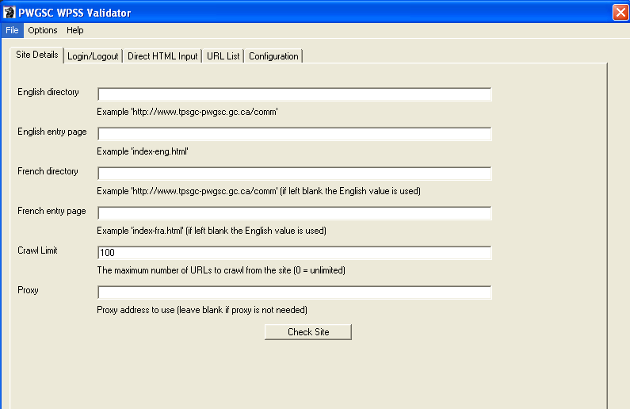

Entry URLs
The English and French URLs for the site along with the entry page names must be entered into the top page of the “Site Details” tab

English Directory – This is the English URL to the directory containing all of the site’s documents (HTML documents, image files, css files, etc.). Examples,
- http://www.tpsgc-pwgsc.gc.ca/comm/index-eng.html the English Directory is http://www.tpsgc-pwgsc.gc.ca/comm/

- http://source.tpsgc-pwgsc.gc.ca/policy/text/index-e.html the English Directory is http://source.tpsgc-pwgsc.gc.ca/policy/

- http://id-reo.tpsgc-pwgsc.gc.ca/public/ffchrdspl.do?page=acclhm&lang=en the English Directory is http://id-reo.tpsgc-pwgsc.gc.ca/public/

- http://crownassets.pwgsc.gc.ca/mn-eng.cfm?snc=hm the English Directory is http://crownassets.pwgsc.gc.ca/

English Entry Page – The directory and file name of the English entry page. This is not the full URL, just the directory, file name and arguments portion. The entry page name can be found by viewing the site’s splash page to get the URL referenced by the English language button. For example
- http://www.tpsgc-pwgsc.gc.ca/comm/index-eng.html the English Entry Page is index-eng.html.

- http://source.tpsgc-pwgsc.gc.ca/policy/text/index-e.html the English Entry Page is text/index-e.html

- http://id-reo.tpsgc-pwgsc.gc.ca/public/ffchrdspl.do?page=acclhm&lang=en the English Entry Page is ffchrdspl.do?page=acclhm&lang=en.

- http://crownassets.pwgsc.gc.ca/mn-eng.cfm?snc=hm the English Entry Page is mn-eng.cfm?snc=hm.

French Directory – This is the French URL to the directory containing all of the site’s documents (HTML documents, image files, css files, etc.). If the French Directory is the same as the English Directory, it can be left blank. Examples,
- http://www.tpsgc-pwgsc.gc.ca/comm/index-eng.html the French Directory can be left blank, as it is the same as the English directory.

- http://source.tpsgc-pwgsc.gc.ca/politique/text/index-f.html the French Directory is http://source.tpsgc-pwgsc.gc.ca/politique. Since the directory name politique differs from the English name, policy, the French directory must be specified.

- http://id-reo.tpsgc-pwgsc.gc.ca/public/ffchrdspl.do?page=acclhm&lang=fr the French Directory can be left blank as it is the same as the English directory.

- http://biensdelacouronne.tpsgc.gc.ca/mn-fra.cfm?snc=hm the French Directory is http://biensdelacouronne.tpsgc.gc.ca. The site has separate English and French domain names.

French Entry Page – The directory and file name of the French entry page. This is not the full URL, just the directory, file name and arguments portion. The entry page name can be found by viewing the site’s splash page to get the URL referenced by the French language button. For example
- http://www.tpsgc-pwgsc.gc.ca/comm/index-fra.html the French Entry Page is index-fra.html.

- http://source.tpsgc-pwgsc.gc.ca/politique/text/index-f.html the French Entry Page is text/index-f.html

- http://id-reo.tpsgc-pwgsc.gc.ca/public/ffchrdspl.do?page=acclhm&lang=fr the French Entry Page is ffchrdspl.do?page=acclhm&lang=fr.

- http://biensdelacouronne.tpsgc.gc.ca/mn-fracfm?snc=hm the French Entry Page is mn-fra.cfm?snc=hm.

Crawl Limit – The maximum number of URLs the tool will retrieve and analyse from the site. The URLs include all file types, HTML, PDF, images, CSS files, etc. If the value 0 is specified then the entire site will be crawled.

Login/Logout Pages
The WPSS Tool can crawl application sites that have a simple login page consisting of a single form for login credentials. If the site to crawl does have a login, then the following additional data items must be entered. If the site does not have a login, these fields should remain blank.

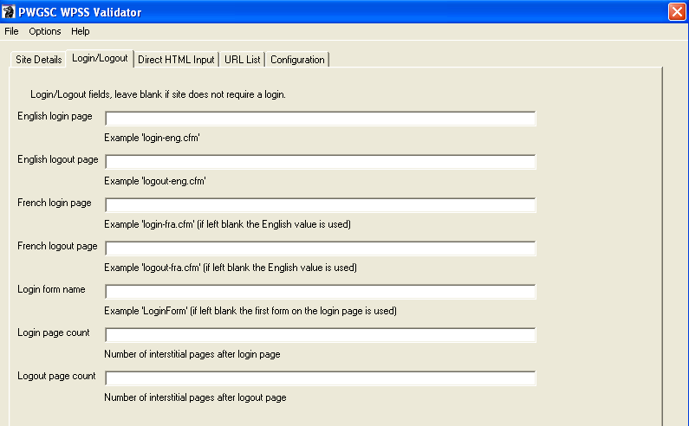

Login/Logout URLs

English Login Page – The directory and file name of the English login page. This is not the full URL, just the directory, file name and arguments portion. For example
- http://crownassets.pwgsc.gc.ca/mn-eng.cfm?snc=hm the English Login Page is mn-eng.cfm?snc=ouv-log&ouvlog=1&vndsld=0.

English Logout Page – The directory and file name of the English logout page. This is not the full URL, just the directory, file name and arguments portion. For example
- http://crownassets.pwgsc.gc.ca/mn-eng.cfm?snc=hm the English Logout Page is mn-eng.cfm?snc=ouv-log&ouvlog=1&vndsld=0.

French Login Page – The directory and file name of the French login page. This is not the full URL, just the directory, file name and arguments portion. For example
- http://biensdelacouronne.tpsgc.gc.ca/mn-eng.cfm?snc=hm the French Login Page is mn-fra.cfm?snc=ouv-log&ouvlog=1&vndsld=0.

French Logout Page – The directory and file name of the French logout page. This is not the full URL, just the directory, file name and arguments portion. For example
- http://biensdelacouronne.tpsgc.gc.ca/mn-eng.cfm?snc=hm the French Logout Page is mn-fra.cfm?snc=ouv-log&ouvlog=1&vndsld=0.

Login Form Name – If the login page contains more than 1 form (e.g. a search form along with the login form), then the name of the form must be specified. The name is the value of the name or id attribute of the form. If there is only 1 form on the login page, this field can be left blank.

Saving Site Details
The above site details can be saved in a configuration file for sharing or easy access for subsequent runs of the tool. This is accomplished by selecting the “Save Site Config” item from the “File” menu. The folder and file name can be specified file chooser dialog. In order to manage site configuration files it is suggested that the configuration files be saved in the profiles folder within the WPSS_Tool folder.

Loading Site Details
A previously saved site configuration can be easily loaded into the “Site Details” fields by selecting the “Load Site Config” item from the “File” menu. Select the file in the file chooser dialog. Once the site details are loaded, they can be used as is, or modified if need be.

Perform Site Crawl and Analyse Documents
Once the site details have been entered and the analysis configuration items have been selected, a crawl of the site can be initiated. By selecting the “Check Site” button on the “Site Details” tab the WPSS Tool begins to crawl the site and analyses each of its documents. The results are provided in the results window.

Direct HTML Analyses
To analyse a single page, the HTML mark up of that page can be entered into the “Direct HTML Input” tab. Once the text has been pasted into the text area, the “Check” button can be used to analyse the HTML content. The analysis configuration options from the “Configuration” tab are used to control the tool and the results appear in the results window.

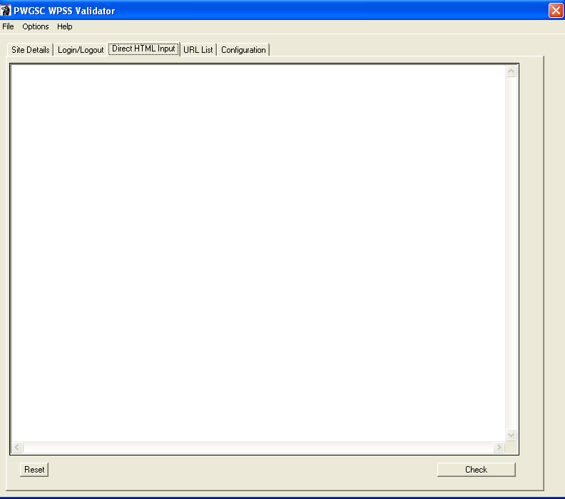

List of URLs
The “URL List” tab allows the user to enter a list of URLs to be analysed. The list of URLs can be types directly into the text area or loaded from a file. The “Check URL List” button begins the analysis each of documents. The results are provided in the results window.
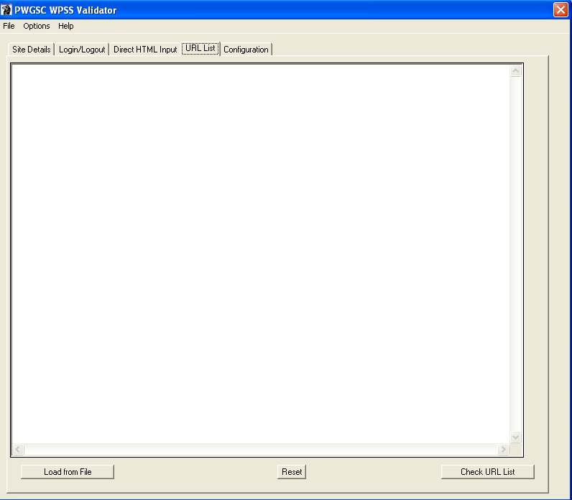

Tool Analysis Configuration
The “Configuration” tab allows the user to select options for the analysis tools.

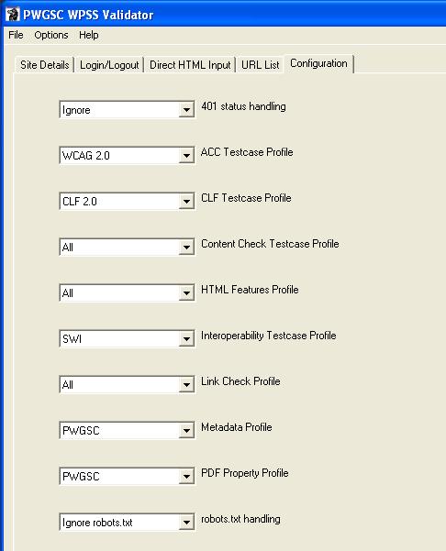

The options include

- 401 status handling – Controls the behaviour of the tool if it encounters a 401 – Not Authorized code.
The selections include
  - Prompt for credentials
  - Ignore

- ACC Testcase Profile – Select the desired Accessibility test case profile. The selections include
  - WCAG 2.0
  - TBS WCAG 2.0 Quick Check (WAAT Tool profile)
  - None

- CLF Testcase Profile – Select the desired look and feel test case profile. The selections include
  - PWGSC SWU (Standard on Web Usability)
  - TBS SWU
  - CLF 2.0
  - None

- Content Check Testcase Profile – Select the appropriate Content Check testcase to validate with. The selections include
  - All – All content check testcases
  - None

- HTML Feature Profile – Select the appropriate HTML feature profile to report on. The selections include
  - All – Report all HTML features
  - None

- Interoperability Testcase Profile – Select the appropriate interoperability testcase profile. The selections include
  - SWI – Standard on Web Interoperability
  - None

- Link Check Profile – Select the appropriate link check testcase profile. The selections include
  - All
  - Errors – report broken links only
  - IPV4 – report IP addresses used as domain names
  - None

- Metadata Profile – Select the appropriate Metadata profile to validate with. The selections include
  - PWGSC SWU – PWGSC Standard on Web Usability
  - TBS SWU – TBS Standard on Web Usability
  - PWGSC – The PWGSC CLF 2.0 Metadata profile.
  - TBS CLF 2.0 – The TBS CLF 2.0 profile.
  - None – No Metadata required.

- PDF Property Profile – Select the appropriate PDF Property profile to validate with. The selections include
  - PWGSC – The PWGSC profile.
  - None – No properties required.

- Robots.txt handling – Controls the behaviour of the tool if it encounters a 403 – Forbidden by robots code.
The selections include
  - Respect robots.txt
  - Ignore robots.txt

These configuration options are not saved with the site information, they must be set before starting the analysis.

Results Window
The “Results Window” contains a number of tabs, each containing the output of an individual analysis tool. The output in each tab includes a header that lists the English and French site directory URLs along with the time and date when the analysis started.

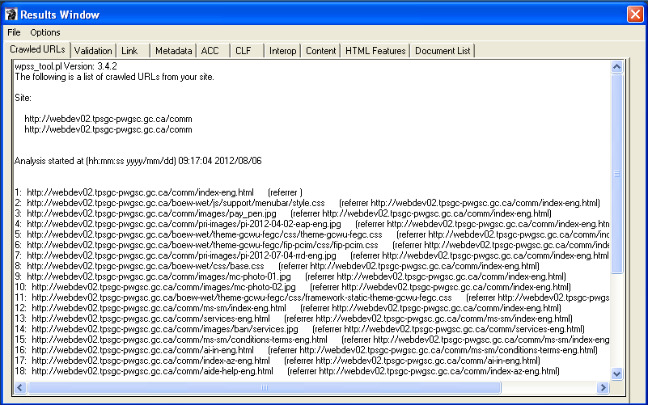

The list of output tabs is:

Crawled URLs – This provides the list of URLs that are analysed by the tool. It lists the referrer page to indicate how the crawler reached a particular page. This tab can be used to monitor the WPSS tool to ensure it is actively crawling and analysing a site’s pages.

Validation – This tab contains the output of the HTML/XHTML, CSS and Robots.txt validation tools.

Link – This tab contains the output of the Link Check tool.

Metadata – This tab contains the output of the Metadata Check tool.

ACC – This tab contains the output of the Accessibility Check tool.

CLF – This tab contains the output of the look and feel check tool.

Interop – This tab contains the output of the interoperability check tool.

Content – This tab contains the output of the Content Check tool.

HTML Features – This tab contains a list of documents that have HTML features like forms, tables, etc.

Document List – This tab is written after the site analysis is complete. It contains the sorted list of documents found in the site. It includes all documents, HTML/XHTML, PDF, images, CSS, etc.

Once the analysis is complete, the time & date is included at the end of the report in each tab.

Saving Analysis Results
To save the analysis results, select the “Save As” item from the “File” menu in the Results window. Select the file name and folder path in the file chooser dialog. The results are stored in a number of files, one for each result tab. Each file name will contain a suffix identifying the report type. For example, if the results are to be saved in the file www_corp.txt, the actual results files will be

- www_corp_crawl.txt
- www_corp_val.txt
- www_corp_link.text
- www_corp_meta.txt
- www_corp_acc.txt
- www_corp_clf.txt
- www_corp_swi.txt
- www_corp_feat.txt
- www_corp_urls.txt

In addition to the above results, some HTML reports are also generated and saved with the result files.

- www_corp_img.html – Image Details report
- www_corp_h.html – Headings Outline report

It is suggested that the base name of the results be the same as the site profile name and that the results are stored in the results folder in the WPSS_Tool folder.

Stopping Crawler and Analysis
To stop the crawler and analysis tools while they are running, select the “Stop Crawl” item in the “Options” menu in the results menu. This will stop the tool after the current document is processed and add a note to the bottom of each output tab indicating that analysis was aborted.

Application Login
If the site being analysed is an application with a login page (specified in the Site Details tab of the main window) the tools must be able login to the application in order to view pages behind the login. When the English login page is reached, the user is presented with a Login window in order to provide application credentials. All of the input fields listed in the login form are presented to the user in a login window. The order of the fields may be different than what appears on the web page.

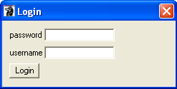

Once the credentials are provided and the “Login” button is selected, the WPSS tool attempts to login to the application site. The user is not prompted for login credentials for the French login page rather the English credentials are reused.

Web Server Protected Sites
If the site being analysed contains directories that are password protected by the web server using Basic Authentication, the tool must be able to provide the credentials in order to view the documents. When a document is reached that requires authentication, the user is presented with a Login window in order to provide the credentials.

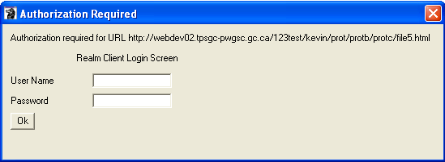

Once the credentials are provided and the “Login” button is selected, the WPSS tool attempts to get the document.

Reporting Passes and Fails
The default behaviour of the analysis tools is to report only on URLs that fail checks. If you wish to see an entry in the results for both passes and fails, the “Report Fails and Passes” item in the “Options” menu of the main window should be selected. The URL for documents that pass checks are then recorded in the results output.

Selecting the “Report Fails Only” item from the “Options” menu of the main window will turn off this feature.

Capture HTML Content on Errors
Sometimes having the URL of a document with errors is not sufficient, especially if the content is generated by an application on the fly. In order to capture the HTML content of a document with errors it is necessary to stop the analysis process when the error occurs. By selecting the “Stop on Error” item in the “Options” menu of the main window, the crawler and analysis tools will stop when an error is detected. Once stopped, the user is presented with an option to save the HTML content or to continue on with the next document. The saved content includes HTML comments at the top of the file providing the full URL of the document along with the tool error message.

Selecting the “Continue on Error” item from the “Options” menu of the main window will turn off this feature.

Command Line Interface
The WPSS tool is available from both the GUI interface (described above) as well as from the command prompt. The command line version is accessed by
- Open a command prompt window
- Change directory to the WPSS Tool installation directory
- Run the program wpss_tool.pl

The wpss_tool.pl program can be used to crawl a site, or validate a block of HTML markup or validate a list of URLs.

Crawl a Site
To crawl a site and validate documents, the command line tool must be invoked as follows:

.\wpss_tool.pl –cli –c <crawl file>

The <crawl file> is the path to a file containing the site details and tool configuration. The configuration file is a plain text file containing variable/value pairs as follows

Variable | Value
site_url_eng | This is the URL to the English entry page.
site_url_fra | This is the URL of the French entry page. If the French Entry Page is the same as the English Entry Page, it can be left blank.
crawllimit | The maximum number of URLs the tool will retrieve and analyse from the site. The URLs include all file types, HTML, PDF, images, CSS files, etc. If the value 0 is specified then the entire site will be crawled.
output_file | The folder and file name that the analysis results are written to.
httpproxy | The HTTP proxy field allows for setting proxy server for HTTP traffic. This field must only be used when the user’s workstation requires a proxy in order to reach the Internet.

Example file contents:

crawllimit 100
site_url_eng http://webdev02.tpsgc-pwgsc.gc.ca/comm/index-eng.html
site_url_fra http://webdev02.tpsgc-pwgsc.gc.ca/comm/index-fra.html
output_file results/webdev02_comm
httpproxy

Crawl a site with a login
In order to crawl a site or application that has a login, additional configuration items must be provided to the WPSS tool. All of the configuration items for crawling a site must be provided along with the following items

Variable | Value
loginpagee | The URL of the English login page.
logoutpagee | English Logout Page – The URL of the English logout page.
loginpagef | French Login Page – The URL of the French login page.
logoutpagef | The URL of the French logout page.
loginformname | If the login page contains more than 1 form (e.g. a search form along with the login form), then the name of the form must be specified. The name is the value of the name or id attribute of the form. If there is only 1 form on the login page, this field can be left blank.

Login credentials must also be provided in a credentials file. The credentials file is a text file containing variable/value pairs for the login form’s text and password fields. The variable names match the name attribute of the various <input> fields.

Sample credentials file:
username admin
password abc123

To crawl a site or application that has a login, the command line tool must be invoked as follows:

.\wpss_tool.pl –cli –c <crawl file> -login <credentials file>

Analyse a block of HTML code
To analyse a block of HTML mark-up, the command line tool must be invoked as follows:

.\wpss_tool.pl –cli –h <html content file>

The < html content file > is the path to a file containing the tool configuration. The configuration file is a plain text file containing variable/value pairs as follows

Variable | Value
html_file | The path of the file containing HTML mark-up to analyse.
output_file | The folder and file name that the analysis results are written to.
httpproxy | The HTTP proxy field allows for setting proxy server for HTTP traffic. This field must only be used when the user’s workstation requires a proxy in order to reach the Internet.

All other lines of the file that begin with either http:// or https:// are the list of URLs to analyse.

Example file contents:

html_file sample.html
output_file results/webdev02_comm
httpproxy

Analyse a list of URLs
To analyse a list of URLs, the command line tool must be invoked as follows:

.\wpss_tool.pl -cli –u <url list file>

The < url list file > is the path to a file containing the list of URLs and tool configuration. The configuration file is a plain text file containing variable/value pairs as follows

Variable | Value
output_file | The folder and file name that the analysis results are written to.
httpproxy | The HTTP proxy field allows for setting proxy server for HTTP traffic. This field must only be used when the user’s workstation requires a proxy in order to reach the Internet.

All other lines of the file that begin with either http:// or https:// are the list of URLs to analyse.

Example file contents:

output_file results/webdev02_comm
httpproxy
http://www.tpsgc-pwgsc.gc.ca/comm/index-eng.html
http://www.tpsgc-pwgsc.gc.ca/comm/index-fra.html

Program Status and Progress
As the command line tool runs and analyses documents, the URLs of the documents are printed to the console. This can be used to monitor the WPSS tool to ensure it is actively crawling and analysing a site’s pages.

Viewing Results
The results of an analysis are stored in a number of files, each file name will contain a suffix identifying the report type. For example, if the results are to be saved in the file webdev02_comm.txt, the actual results files will be

- webdev02_comm _crawl.txt – list of URLs analysed by the tool.
- webdev02_comm _acc.txt – details of WCAG 2.0 faults detected.

It is suggested that the base name of the results be the same as the site profile name and that the results are stored in the results folder in the WPSS_Tool folder.

The results files can be viewed with any program that can display plain text files (e.g. notepad.exe).

Language Switching
The language of analysis results can be controlled by an optional language command line option.

Option | Result
-eng | Analysis results are provided in English.
-fra | Analysis results are provided in French.

If no language selection is made, the language is determined from the operating system installation.

Configuration Files
There are a number configuration files that modify the behaviour of the tool. Most of these files should remain untouched with the exception of the wpss_tool.config file. This file contains the network scope designation for domains as well as the domain and domain alias mapping. The file is a plain text file with simple name value pairs for configuration parameters.

Domain Network Scope
This defines the network scope of a specific domain. The network scope is one of
- Internet
- GC Intranet
- PWGSC Intranet
- Internet development
- GC Intranet development
- PWGSC Intranet development

Domain Alias Map
This provides a mapping of domain names and their aliases.

Trouble Shooting

Entry Page Rewritten
Message | Entry page http://webdev02.pwgsc.gc.ca/comm/index-eng.html rewritten to http://webdev02.tpsgc-pwgsc.gc.ca/comm/index-eng.html
Cause | The entry page provided in the site configuration is redirected by the web server.
Correction | Provide the rewritten entry page URL in the site configuration.

Forbidden by robots.txt
Message | Failed to get url http://ssi-iss.tpsgc-pwgsc.gc.ca/index-eng.html,error is 403 Forbidden by robots.txt
Cause | The site has a robots.txt file that prohibits crawlers from accessing the site. The WPSS Tool honours robots, so is unable to crawl and analyse the site.
Correction | Select the “Ignore robots.txt” value for the “robots.txt handling” item in the Configuration tab.

User Agent String
The validation tools have their own User Agent string that is different from a user’s browser. Some sites look at the User Agent string and present different output depending upon its value (e.g. check for a minimum browser version).

Message | Varies
Cause | The validation tools User Agent string not recognized by the site being analysed.
Correction | Change site to not depend on a specific User Agent string and/or browser.

Perl Command Line Interpreter Error
The WPSS Tool uses a number of Perl modules. These modules may have errors that cause the program to fail. The following dialog may be encountered

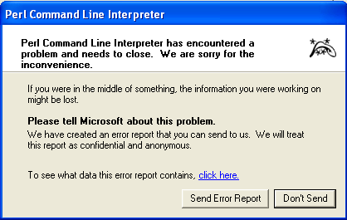

Message | Perl Command Line Interpreter has encountered a problem
Cause | An error in the supporting Perl modules..
Correction | Restart the WPSS Tool, if the problem persists contact PlanificationWeb-WebPlanning@tpsgc-pwgsc.gc.ca

500 Internal Server Error
When analysing some sites the WPSS Tool may report a “500 Internal server error”. This may be due to a limitation on the Web server, and not the WPSS tool. The "500 Internal server error" problem may be due to the Web server not handling the "Range" setting in the HTTP GET operation. The WPSS Tool sets a size limit on GET operations, to avoid getting extremely large documents. In order to avoid this error a configuration setting can be changed to not include the “Range” setting in a HTTP GET operation.

This can be avoided through a setting in a configuration file. Using a simple text file editor (e.g. WordPad)

- Open the file
conf\wpss_tool.config

- Locate the following lines in the file

#
# Set Max User Agent Size 0 so we can accept documents of any size.
# This also removes the Range field from the HTTP header.
#
#User_Agent_Max_Size 0

- Remove the leading ‘#’ character from the ‘#User_Agent_Max_Size 0’ line.

This functionality is not available via the user interface, only by directly editing the configuration file.

